# **Project 2**

# **Keerthana Bhuthala Santhi Sushma Katragadda**

# **5251-1292 1748-9431**

**Graphs:**

Below are two graphs for gossip and push sum algorithm for all six topologies.

Gossip Algorithm:

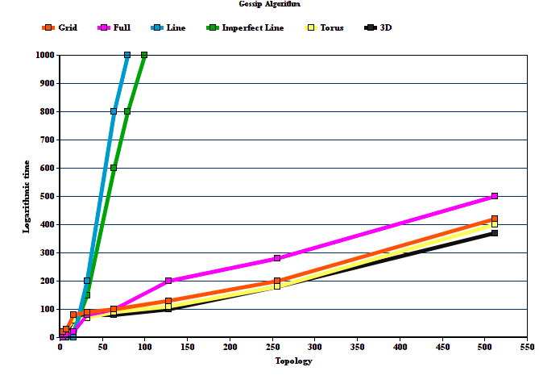

2D

The log of Convergence times of the Gossip algorithm vs the number of nodes in various topologies is plotted in the above graph.

**Push Sum Algorithm**

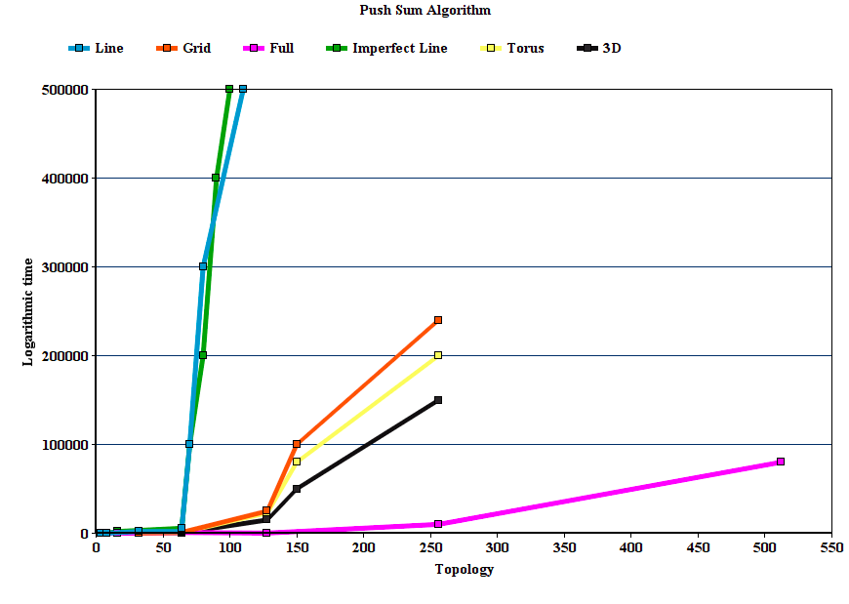

2D

The log of Convergence times of the Push-Sum algorithm vs the number of nodes in various topologies is plotted in the above graph. We are calculating convergence time by subtracting end time of program and when the function is called to create topology.

**Findings:**

As we see here Line and imperfect line has a steep increase in time for both gossip and push sum algorithm. For gossip algorithm, grid, torus and 3D were efficient and for push sum Full network was efficient. Each topology is efficient for different scenarios.

**Interesting Observations made:**

* In the line topology, each node has a maximum of two neighbors. Due to this, the rumour is spread very slow in the network. Therefore, this results in the maximum convergence time in Line topology in both Gossip and PushSum algorithms.
* As the number of nodes are increasing, the minimum convergence time is observed in 3D topology in Gossip algorithm and in full topology in PushSum algorithm respectively.
* Theoretically, we assumed that the full topology might have the minimum convergence time, but practically, after running the code, we observed that the full topology do not have the minimum convergence time.